21.93: a) The y-components of the electric field cancel, and the x-components from both charges, as given in problem 21.87 is:
If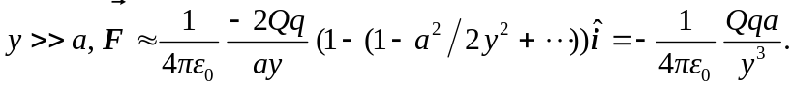
b) If the point charge is now on the x-axis the two charged parts of the rods provide different forces, though still along the x-axis (see problem 21.86).
So,
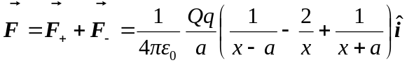
For 